Lab#5 Build a personal portfolio (CV) webpage using HTML and CSS and make it responsive using Media Query.

TAGS USED | ATTRIBUTES USED | DESCRIPTION
<HTML> | -- | Defines the root of an HTML  document.
<HEAD> | -- | Contains meta-information/  metadata about the  document.
<TITLE> | -- | Specifies a title for the HTML  page shown in the browser  toolbar.
<STYLE> | -- | Contains CSS code used to  style the webpage.
<BODY> | -- | Contains the visible content  of the webpage.
<DIV> | Class | Defines a section or  container. class is used for  CSS styling and id uniquely  identifies a section.
<HEADER> | Class | Defines the header section of  the webpage.
<H1> TO <H6> | Class | Defines a Size of headings.
<P> (Paragraph) | -- | Defines a paragraph of text.
<IMG> | Src, alt, Class | Displays an image. src  specifies the image URL,  while alt provides alternative  text.
<UL> | -- | Creates an unordered  (bulleted) list.
<LI> | -- | Defines an item in a list.
<P> | -- | Defines a paragraph of text.

Final Outcome:

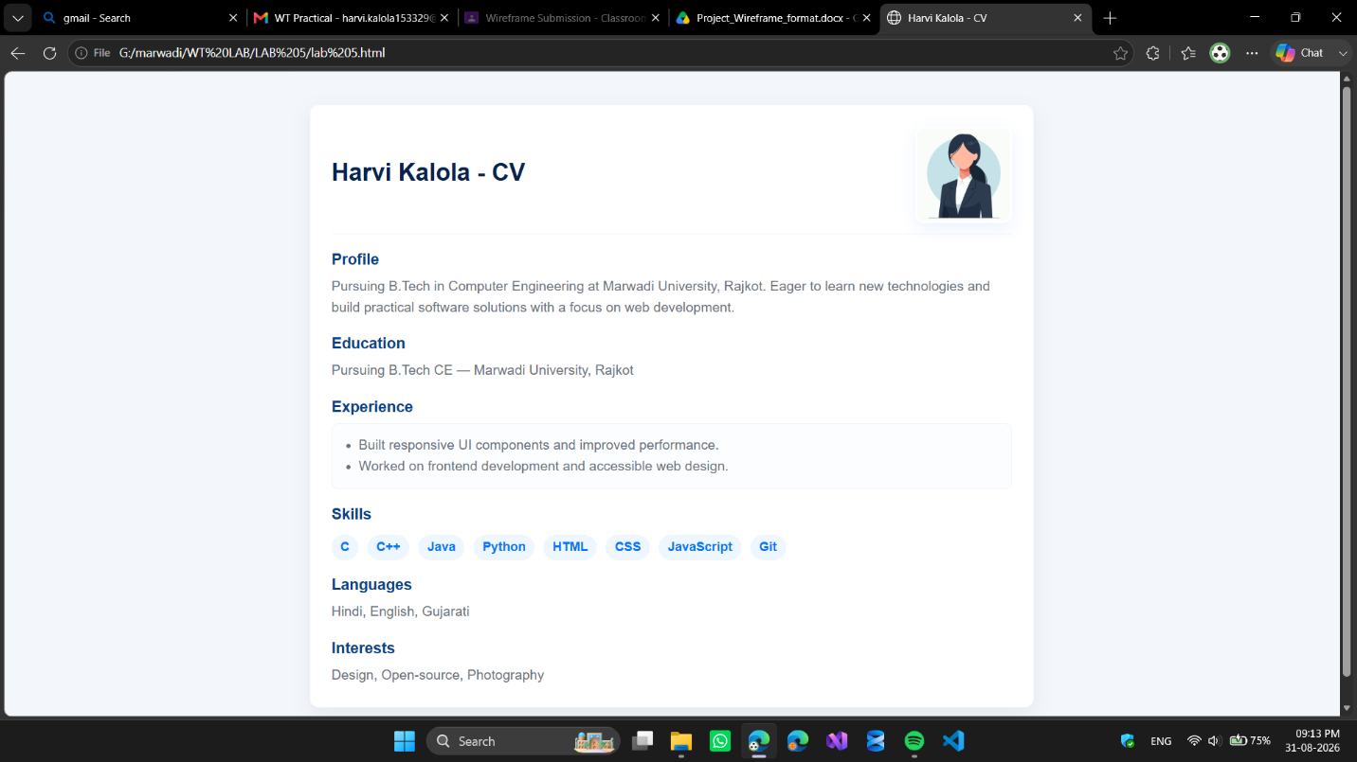

Code Snippet:

<html>
<head>
<title>Harvi Kalola - CV</title>
<style>
body {
font-family: Arial, Helvetica, sans-serif;
background: #f3f6fb;
color: #111827;
padding: 20px;
}
* {
box-sizing: border-box;
margin: 0;
padding: 0;
}
.card {
max-width: 820px;
margin: 18px auto;
background: #ffffff;
border-radius: 10px;
box-shadow: 0 8px 22px rgba(0, 0, 0, 0.06);
overflow: hidden;
border: 1px solid #eef4ff;
}
.content {
padding: 24px;
}
.header {
display: flex;
align-items: center;
justify-content: space-between;
gap: 18px;
padding-bottom: 12px;
border-bottom: 1px solid #eef4ff;
}
.header-info {
flex: 1;
text-align: left;
}
.name {
font-size: 1.7rem;
color: #07224d;
margin-bottom: 4px;
}
.role {
color: #0b76f3;
font-weight: 700;
margin-bottom: 6px;
}
.address {
font-size: 0.92rem;
color: #6b7280;
line-height: 1.5;
font-style: normal;
}
.photo {
width: 110px;
height: 110px;
border-radius: 10px;
object-fit: cover;
border: 3px solid #ffffff;
box-shadow: 0 6px 18px rgba(11, 108, 243, 0.08);
}
.block {
margin-top: 18px;
}
.block h2 {
font-size: 1.08rem;
color: #0b3f85;
margin-bottom: 8px;
}
.block p,
.block li,
.block address {
color: #6b7280;
line-height: 1.6;
font-size: 0.96rem;
}
ul {
margin-left: 18px;
}
.job {
background: #fbfdff;
border: 1px solid #eef4ff;
border-radius: 8px;
padding: 12px;
}
.skill-item {
display: inline-block;
background: #eef6ff;
color: #0b76f3;
padding: 6px 10px;
border-radius: 999px;
margin: 5px 6px 0 0;
font-size: 0.9rem;
font-weight: 600;
}
@media (max-width: 600px) {
.header {
flex-direction: column;
text-align: center;
}
.header-info {
text-align: center;
}
}
@media print {
body {
background: white;
padding: 0;
}
.card {
box-shadow: none;
border: none;
}
}
</style>
</head>
<body>
<div class="card">
<div class="content">
<header class="header">
<div class="header-info">
<h1 class="name">Harvi Kalola - CV</h1>
</div>
<img src="G:\marwadi\WT LAB\LAB 5\img.avif" alt="Harvi"
class="photo">
</header>
<div class="block">
<h2>Profile</h2>
<p>Pursuing B.Tech in Computer Engineering at Marwadi
University, Rajkot. Eager to learn new technologies and build practical software
solutions with a focus on web development.</p>
</div>
<div class="block">
<h2>Education</h2>
<p>Pursuing B.Tech CE — Marwadi University, Rajkot</p>
</div>
<div class="block">
<h2>Experience</h2>
<div class="job">
<ul>
<li>Built responsive UI components and improved performance.</li>
<li>Worked on frontend development and accessible web design.</li>
</ul>
</div>
</div>
<div class="block">
<h2>Skills</h2>
<div>
<div class="skill-item">C</div>
<div class="skill-item">C++</div>
<div class="skill-item">Java</div>
<div class="skill-item">Python</div>
<div class="skill-item">HTML</div>
<div class="skill-item">CSS</div>
<div class="skill-item">JavaScript</div>
<div class="skill-item">Git</div>
</div>
</div>
<div class="block">
<h2>Languages</h2>
<p>Hindi, English, Gujarati</p>
</div>
<div class="block">
<h2>Interests</h2>
<p>Design, Open-source, Photography</p>
</div>
</div>
</div>
</body>
</html>

